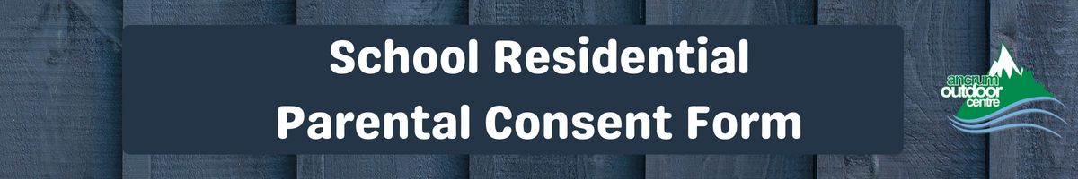
About You: (Please Print)
Name: |  |  | Date of Birth:
Address, with postcode
Mobile No:
Email Address:
Who to contact in emergency (2 people required)
Contact ①
Name:
Address:
Tel No:
Contact ②
Name:
Address:
Tel No:
Medical Information
Please detail any medical conditions, including allergies:
Please detail any medication that you may require to carry and / or self administer:
Additional Support
Please detail any additional support required:
Photo Consent
Leisure & Culture Dundee are committed to providing quality, safe programmes and activtities for all participants through the effective implementation of policy.
Members of the public are not permitted to take photographs at Leisure & Culture events. Leisure & Culture Dundee operates a policy of obtaining consent to enable officers and members of the press to take photographs for official use only. Your details will be retained on a database for use only by Leisure & Culture Dundee. These details will not be passed to any other agency or third party.
These images may be used on Leisure & Culture Dundee website and associated websites, promotional material or social media for promotional purposes only.
Please tick the box if you DO NOT give permission for your photograph to be taken: 

Leisure & Culture Dundee will administer basic emergency first aid in accordance with the relevant medical authorities. This however, will exclude administration of all medicines, except agreed use of EpiPen.
Leisure & Culture Dundee asks participants and their carers to adhere to its Codes of Conduct to ensure the health, safety and enjoyment of all participants. Failure to do so could result the participant being excluded from the activity.
If you DO NOT wish to receive information on other programmes and activities run by Leisure & Culture Dundee (please tick box): | 
Data Protection Information:
The personal information you provide will be held by Leisure and Culture Dundee.
The personal information will be used for the following purposes:
- To contact you about your chosen course or activity
- To provide statistical information about users of the service research
- To provide relevant medical information to staff or emergency services in the event of an accident/ incident.
- For the prevention and detection of crime.
If you have any questions about our Data Protection Policy or the information we hold about you, please contact us on 01382 307485 or email: dataprotection@leisureandculturedundee.com

Declaration:
- I agree to myself or my son/daughter receiving any emergency medical, surgical and dental treatment including anaesthetic and blood transfusion, that may be considered necessary by the attending medical authorities. (Parents or participants with objections to the administration of blood products should contact the Outdoor Learning Manager at Ancrum prior to activity on 01382 435911).
- I declare that there is no reason, medical or otherwise why I / my child should not take part in this course, and I undertake that I have declared the details of any medical treatment I / my child is receiving and any other matters of which the centre staff should be aware.
- I undertake to notify Ancrum in the event of any changes in fitness or health that may take place prior to the activity.
- I accept that personal belongings, including electronic, mobile phone and photographic equipment, are not covered by Ancrum insurance and that these specific items are carried at your own risk. Ancrum will not be held liable for damage to, or loss of, these items.
- I understand that if my anyone’s behaviour jeopardises their own safety or the safety of others, they may be removed from the activity and any additional costs incurred as a result of their actions may be recovered from me.
- I acknowledge if the course is an adventure activity with Ancrum the fact that whilst Ancrum Outdoor Centre staff will make every effort to care for the safety of you or your son/daughter, adventurous activities can be dangerous and calculated risk is an intrinsic element of Adventure Activities, risk can never be entirely omitted.
I declare that the information given in this form is correct at the time of writing (please tick box): | 
I confirm that I have read and acknowledge the codes of conduct, declaration and data protection information (please tick box): | 

Signed: |  | Date:

